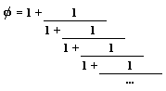
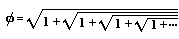
The golden ratio can be represented as the simplest continued fraction or as a repeated square root
The Golden Rectangle and the Golden Ratio http://www.jimloy.com/geometry/golden.htm
a
a
b

This diagram shows a golden rectangle (roughly). I have divided the rectangle into a square and a smaller rectangle. In a golden rectangle, the smaller rectangle is the same shape as the larger rectangle, in other words, their sides are proportional. In further words, the two rectangles are similar. This can be used as the definition of a golden rectangle. The proportions give us: a/b = (a+b)/a = φ = $\left(\frac{1+\sqrt{5}}{2}\right)$
The golden rectangle is found in some art, especially 20th Century art. But, it would seem that ancient Greek architects did not consciously use it. The Parthenon is the most famous example of the use of the golden rectangle. But, the fit is not particularly good. And, almost any rectangle can be found in pictures of the Parthenon
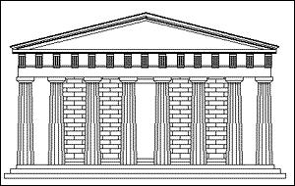
Divina proportio
φ

